



Addressing Climate and El Niño-related Risks in Southeast Asia: A Swiss Development Cooperation initiative on science-based, risk-informed and climate-smart development

Bangkok, 4 October 2024 – The Swiss Agency for Development Cooperation (SDC), in collaboration with the Asian Disaster Preparedness Center (ADPC) and Geoneon, today launched an innovation project “Addressing Climate and El Niño-related Risks in Southeast Asia (ACER-SEA)”, which will address development and disaster management challenges in Southeast Asia.

The Switzerland Ambassador to Thailand, Pedro Zwahlen, launched the project and emphasized that “Switzerland remains committed to supporting Southeast Asia in addressing climate change challenges, and through the ACER-SEA project, we aim to empower local populations to adapt to changing climate conditions and take timely actions.”

ADPC’s Executive Director, Hans Guttman, highlighted that “ADPC is proud to reaffirm its ongoing dedication to collaborating with SDC and to enhance climate resilience in Southeast Asia. These efforts leverage ADPC’s specialized expertise in satellite data and tools while being tailored to meet local needs. We are working together to create impactful solutions that address the unique challenges of the region.”


The Switzerland Ambassador to Thailand, Pedro Zwahlen (right), and ADPC’s Executive. Director, Hans Guttman during ACER-SEA launch. Credit: ADPC
The launch ceremony was witnessed by the SDC Head of the Regional Hub in Bangkok, Philippe Brunet, ADPC Deputy Executive Director Aslam Perwaiz, SDC Senior Regional Programme Manager, Erik Kjaergaard and ADPC Director of Risk Analytics & Climate Services Peeranan Towashiraporn.

ADPC is partnering with Geoneon –“New Earth”– which specializes in advanced geospatial solutions to map climate, physical risks, and vegetation to provide clear, actionable insights for informed decision-making.

The CEO and Co-Founder of Geoneon, Roxane Bandini-Maeder, stated: “We are proud to contribute Geoneon’s expertise in geospatial data and AI to strengthen climate resilience in Southeast Asia. This project and partnership will empower local communities and decision-makers with the tools they need to better prepare for, adapt to, and respond to climate risks”.


Utilizing advanced geospatial data from Earth observations and Artificial Intelligence, the ACER-SEA project will strengthen regional cooperation and enhance disaster and climate resilience at subnational levels involving local governments, key decision-makers, and disaster risk management organizations.

At the launch of the ACER-SEA initiative, discussions focused on innovative solutions for climate resilience and disaster risk reduction. Credit: ADPC

In Southern Laos, the project focuses on development initiatives, while in West Sumatra, Indonesia, it enhances disaster preparedness and response strategies. The project seeks to strengthen risk-informed, climate-resilient decision-making in disaster management and sustainable development with wider implications for the Lower Mekong and Southeast Asian regions.

The ACER-SEA project builds on the strong foundations laid by ADPC initiatives such as SERVIR Southeast Asia (SERVIR SEA), which has earned the trust of stakeholders and enhanced climate resilience across the region, as well as the advanced technical capability of Geoneon.

This project is well-positioned to share disaster and climate data by leveraging the extensive networks of ADPC and SDC, such as partnerships with the Association of Southeast Asian Nations

(ASEAN) and the Mekong River Commission (MRC). Together, these partnerships ensure that disaster and climate risk data reach communities and decision-makers to respond effectively to existing or emerging climate challenges.
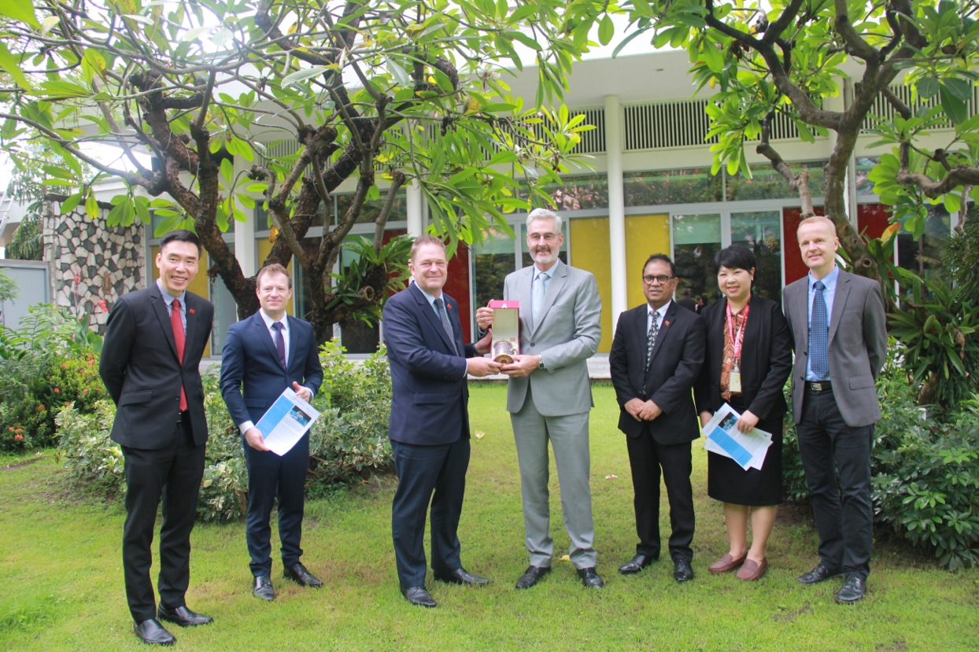
ADPC presents a gesture of appreciation to Switzerland’s Ambassador to Thailand, Pedro Zwahlen, symbolizing the strong partnership and
shared commitment to enhancing disaster resilience and climate adaptation efforts in Southeast Asia. Credit: ADPC

The ACER-SEA project is expected to significantly improve the availability and accessibility of reliable high-resolution data on floods, landslides, climate, exposure, and vulnerability.

This enhancement will pave the way for the creation of science-based early warning systems, anticipatory action, and forecast-based financing. Ultimately, these advancements will empower communities and decision-makers to respond proactively to climate-related risks.

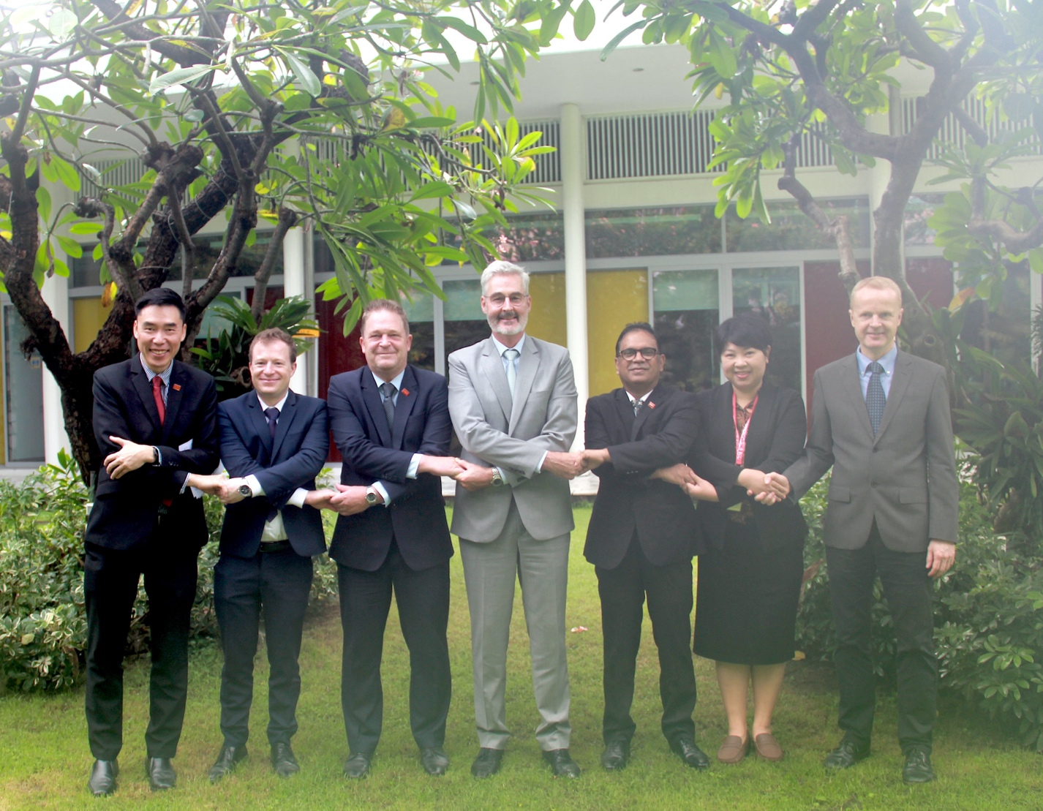
ADPC and SDC join hands, reaffirming their collective commitment to addressing Climate and El Niño-related Risks in Southeast Asia through cooperation and mutual support. Credit: ADPC

